**Assignment 1**

Name: Deepan Sanghavi, Kevin Pinto, Maanas Baijal, Yanhong Huang

Note: Used Excel pivot operation and SQL to do all the analysis

1. Do a profit analysis by machine for the machines at WPI. Which machines/locations are most profitable? Which machines/locations are least profitable?

Profit Analysis done based on Machine, Machine Type and Location. Also, results are sorted based on profit which helps in better understanding the insights from visualization. Moreover, we provided filters which can be seen in excel which assist user to interact with visualization and find specific insights.

Formula of Profit= (Selling Price) * (Restock Quantity) – (Cost Price) * (Restock Quantity) – (Stales Count) * (Cost Price)

Inference: Machine type 2 makes more profit than Machine type 1.

1. How does usage (represented by stocking and stales) differ for machines at malls vs. companies vs. schools (WPI)?

We calculated Usage of machines at mall, schools and companies using following formula:

Usage= Restocking count – Stales count

We used pie chart because that gives better analogy between several departments. Also, provided Month name, Machine Category and Product as the filter to discover specific insights about the usage.

Inference: Usage at school is far more than other two areas.

1. Do machines differ by the number of stales? Which ones have the higher number of stales? Which ones have lower number of stales?

We have analyzed stales count over here based on Location, Machine category and Machine I’d.

Inference: Stale food counts of Machine type 2 i.e. snacks is more than machine type 1. Also, in companies, stale count is max compared to school and mall.

1. What are the managerial implications of these results? In other words, based on the results of your analyses, what are your three major recommendations to the manager of the vending machine company to improve their profit? Explain.

Recommendations:

* As you can see from the third question, number of stales is lot more in snack machines and also, those machines are making most of the profit. So, we can increase the profit further by reducing the number of stales count. One of the method to do that is reducing the stocks in machines such that it doesn’t effect the profit. Moreover, number of stales in January is more than in December. Hence, we should also consider time when we are deciding about by what factor we should reduce the machine capacity.

Formula: Reduce the capacity of machine by how many percent? : ((Total number of stales as per brand and as per month) / (Total Number of restock as per brand and as per month)) * 100

* From the second question, we can say that usage in schools is lot more than company and mall. Even after filtering values based on month and products, School has highest amount of usage. Hence, Manager should invest in schools to gain higher profit. Specifically, machine type 2 has higher usage than machine 1.
* Machine type 1 i.e. Cold drinks has less amount of profit in all departments. More specifically, it has least profit in companies. Hence, we can reduce the number of machines of type 1 and instead, increase the quantity of other machine as there are no stales in such type of machines

SQL Part

1. Created three dimension tables and One Fact table in Google BigQuery and loaded data successfully



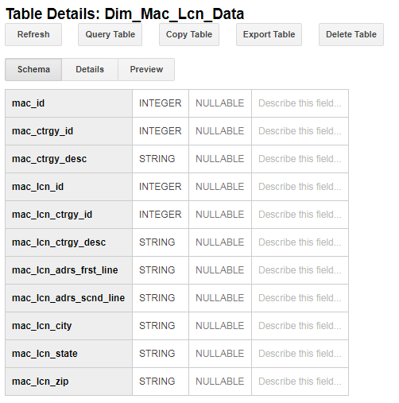

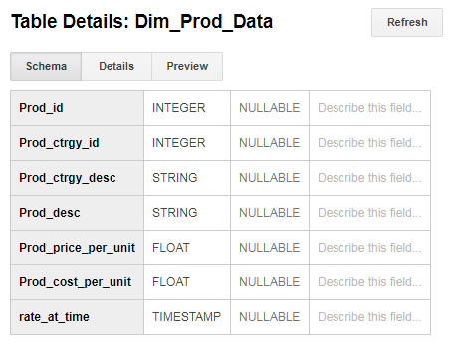

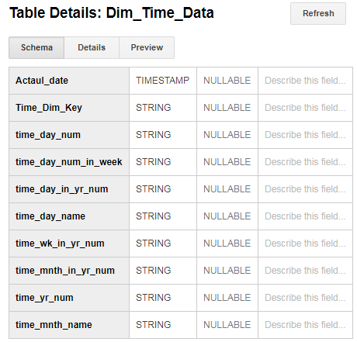

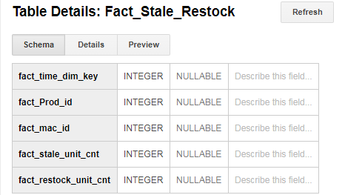

1. SQL queries
   1. 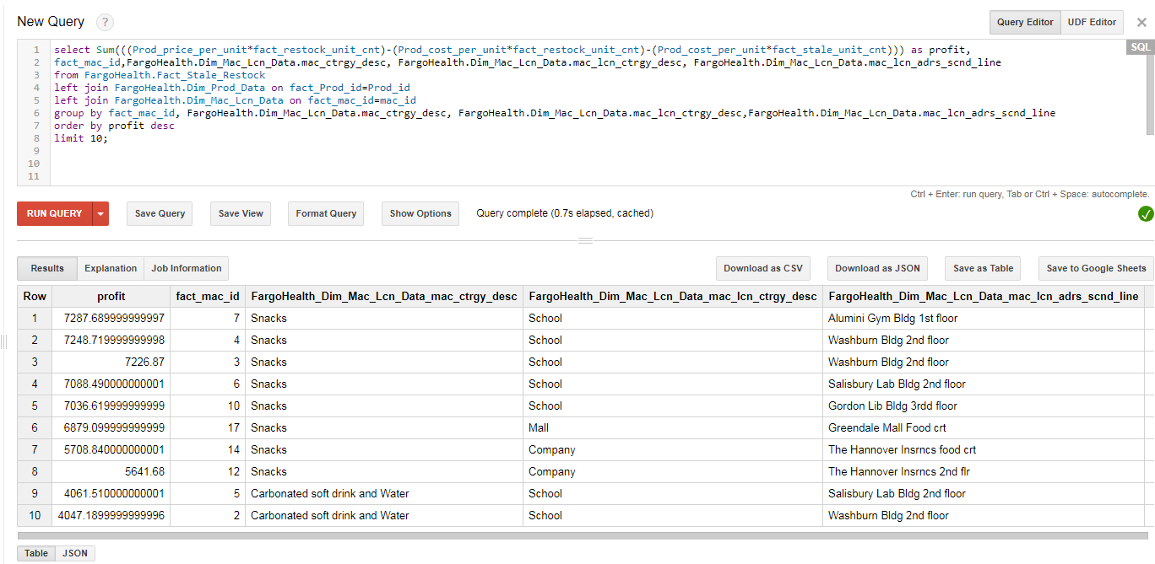Top 10 profit machine, product category, location category and location
   2. usage=restock-stale in different location categories

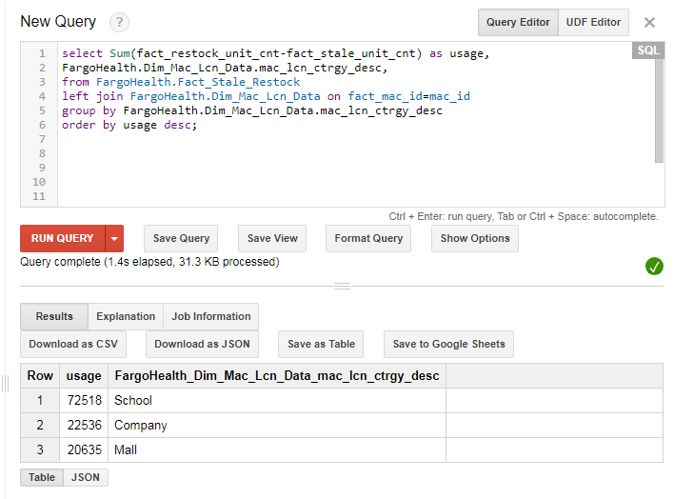

* 1. top 10 of the number of stales( from high to low)

